Assignment Workbook

Winter 2020

Revision History

|  |  |  |  |
| --- | --- | --- | --- |
| **Date** | **Issue** | **Description** | **Author** |
| February 7, 2020 | Assignment 2 | Adding Glossary | Omar Benhmuda |
| February 7, 2020 | Assignment 2 | Adding system actors | Omar Benhmuda |
| February 8, 2020 | Assignment 2 | Adding system use cases | Omar Benhmuda |
| February 8, 2020 | Assignment 2 | Adding use case diagram | Omar Benhmuda |

Table of Contents

iCLINIC System Glossary 4

1.1 Introduction 4

1.2 Glossary 4

iCLINIC System Actors 5

iCLINIC System Use cases 6

iCLINIC System Use Case Diagram 7

List of Candidate Class 8

# iCLINIC System Glossary

## Introduction

This document is used to define terminology specific to the problem domain, explaining terms, which may be unfamiliar to the reader of the use-case descriptions or other project documents. Often, this document can be used as an informal *data dictionary*, capturing data definitions so that use-case descriptions and other project documents can focus on what the system must do with the information.

## Glossary

The glossary contains the working definitions for the key concepts in the iCLINIC System.

|  |  |
| --- | --- |
| **Term** | **definition** |
| Authentication | Authentication is the process of determining whether someone or something is, in fact, who or what it is declared to be. |
| User account | A user is a person who uses iCLINIC system. Each user should have an account in order to be identified by iCLINIC. To login to an account, a user is typically required to authenticate himself/herself with a password or other credentials for the purposes of accounting, security, logging, and resource management. |
| User friendly interface | It is a computer application screen that makes it easier for novices to use this application. Menu-driven programs, for example, are considered more user-friendly than command-driven systems. Graphical user interfaces (GUIs) are also considered user-friendly. |
| Physicians | A physician is a professional who practices medicine, which is concerned with promoting, maintaining or restoring human health through the study, diagnosis, and treatment of disease, injury, and other physical and mental impairments. |
| Digital ink | Refers to technology that digitally represents handwriting in its natural form. In a typical digital ink system, a digitizer is laid under or over an LCD screen to create an electromagnetic field that can capture the movement of a special-purpose pen, or stylus, and record the movement on the LCD screen. The effect is like writing on paper with liquid ink. The recorded handwriting can then be saved as handwriting or converted to typewritten text using handwriting recognition technology. |
| UI component | UI stands for User Interface. It is a junction between a user and a computer program. An interface is a set of commands or menus through which a user communicates with a program. |
| PDF Document | Portable Document Format (PDF) is a file format used to present and exchange documents reliably, independent of software, hardware, or operating system. |
| Pen-based document | Any document that is created using tablet and stylus as pointing devices in addition to handwriting recognition capability. |
| Windows-based desktop computers | A desktop computer is a personal computer powered by Microsoft Windows operating system in a form intended for regular use at a single location desk/table due to its size and power requirements. |
| Tablet PCs | A tablet PC, commonly shortened to tablet, is a mobile computer with a touchscreen display, circuitry, and battery in a single device. |

# iCLINIC System Actors

The first useful step to analyze the system functionality is to look in the problem statement at the things that interact with the system. In UML use case analysis, these external things are called **actors**. Actors are identified based on the following:

* Actors are always external to the system – they are therefore outside our control.
* Actors interact directly with the system.
* Actors represent roles that people and things play in relation to the system, not specific people or specific things.
* Each actor has a unique name and description.

|  |  |
| --- | --- |
| **Actor** | **Description** |
| iCLINIC User | A general user interacting with iCLINIC system. This general user can be a doctor, a nurse, or the system administrator. We will use the name “worker” to refer to a doctor or a nurse. In order to this general user to use iCLINIC, he/she needs to successfully login to the system. |
| iCLINIC Admin | A special type of iCLINIC User who is responsible for ensuring around-the-clock technical maintenance and support. This normally includes maintaining workers accounts and the connectivity issues with the drugs management system. |
| iCLINIC Worker | A special type of iCLINIC User who wish to use iCLINIC system to automate the paper-based processes and to speed up its data entry related tasks. |

# iCLINIC System Use cases

|  |  |
| --- | --- |
| **Use Case** | **Description** |
| Authenticate User | iCLINIC shall provide a functionality to authenticate its user by using a pen only. The user taps his name and can "ink" his password in the box. The user can of course also type (typically using the on-screen keyboard) into the box if desired. Once the user has logged in, the set of controls dynamically changes to match the permissions of this account. Note that, each user should be successfully authenticated before using any of iCLINIC functionalities. |
| Manage Worker Account | iCLINIC shall provide the functionality for the system administrator to create user accounts for doctors and nurses to use iCLINIC according to a set of access controls predefined for each user type. The administrator account itself is shipped with the system. |
| Display iCLINIC Board | iCLINIC shall provide the functionality for its workers to show a list of existing patients corresponding to the geographic unit view. |
| Assign Patient | iCLINIC shall provide the ability for its workers to browse through the provided list of patients exist in the iCLINIC Board, select one or more patients and assign himself to them. |
| Display Palette | Display Palette UC shall provide a graphical user interface GUI to help simplify the choosing of documents among large number of potential documents. It's one tablet screen in size so the user can see all choices in one view which consists of a series of buttons for the user to tap on. The Palette shall be able to manage larger number of document choices than can fit on one screen. |
| Display My Board | iCLINIC shall provide the functionality for its workers to show only the active patients list of the logged-on worker, and hence My Board view can be different for doctors and nurses. |
| Manage Document | iCLINIC shall allow the workers to create a new document. It is a text-based document and the works shall be able to modify its contents.  This document will be saved in a PDF format and will be tagged with the patient’s a metadata. This metadata includes Patient ID, Date of creation/imported, the user ID of the creator/importer, Modification date, the user ID of the modifier, Brief description.  This UC includes two UCs Manage Text Insertion and Recognize Drug names. |
| Manage Text Insertion | This is a supplier UC for the Mange Document UC that shall allow the workers to insert different types of text into the new and/or the old documents created by the base UC. This text can be any paragraph that describes treatments, drug orders, or prescriptions. |
| Recognize Drug Names | This is a supplier UC for the Mange Document UC that shall allow iCLINIC to recognize generic and brand drug names during the text insertion process to help auto completion capability. This information will be extracted from a common repository managed by the Drugs Management System. |
| Import Images | This UC provides a tool to import images using a scanner or by browsing the internal stored image files into the application. These imported files will then be converted to PDFs, to become a part of the iCLINIC documents repository. |
| Manage Patient Record | This UC shall allow that workers at iCLINIC to maintain (add, modify) patient records. Patient’s record includes (but not limited to) the following information: ID, name, address, date of birth, height, weight, bloodGroup, BedID, Treatment area. Each patient record will be associated with zero or more treatment records and a set of digital documents. |

# iCLINIC System Use Case Diagram

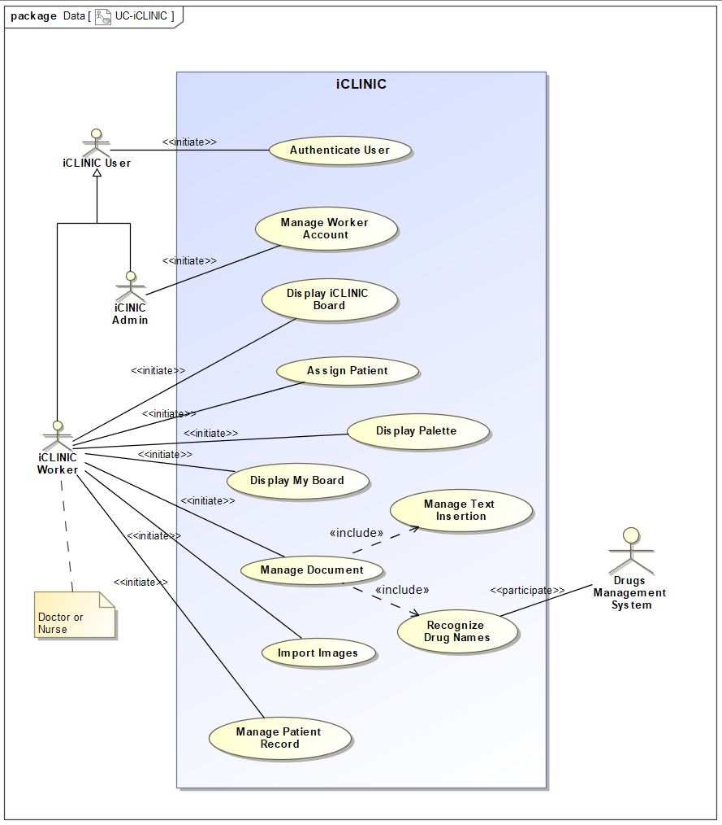

# List of Candidate Class

**List**

Interface, clinician, physician, information, patient, pen, document, tablet PC, digital ink, worker, mouse, keyboard, password, user, controls, Board, list, nurses, palette, screen, buttons, tool, drugs, prescription, images, scanner, files, metadata, ID, date, description, administrator, data, address, weight, height, blood-type, repository.

**Filtered List of Classes**

|  |  |  |
| --- | --- | --- |
| **Class Name** | **Class Type** | **Brief Description** |
| Worker | Entity | Holds Lists and attributes for all users of iCLINIC |
| Patient | Entity | Class which contains all patient information |
| Documents | Entity | Holds all the documents for all patients in the form of a PDF |
| Login | Boundary | User can login through this form to access what their permissions allow |
| LoginController | Controller | Control class to manage the login process and fetching permissions |
| iClinicBoard | Boundary | Brings up a patient list corresponding to the geographic unit view. A worker can assign themselves patients from this board |
| iClinicBoardController | Controller | Controller class for the iCLINIC Board which will fetch patient lists and permissions |
| MyBoard | Boundary | Shows only the active patients list of the logged-on person. Differs from users. |
| MyBoardController | Controller | Controller class for the MyBoard class which will fetch patient lists depending on the user permissions |
| Palette | Boundary | Interface that will allow the user to simplify the choosing of documents among large numbers of potential documents. |
| PaletteController | Controller | Controller class to allow the user to interact with the palette form in order to simplify the documents |
| NewDocumentForm | Boundary | Form where the user can create a new document and choose which patient to add it to |
| NewDocumentFormController | Controller | Data entered into the form will be converted to a pdf and added to the patients list of documents |
| ImageImport | Boundary | User can import and image either by taking a picture or choosing from files on tablet PC |
| ImageImportController | Controller | Controller class for ImageImport which will contain the code to allow user to access the tablets camera or import pictures from tablets files. |
| AddPatientForm | Boundary | User can add a new patient to the patient list. Patient information sections include but are not limited to; ID, name, Adress, date of birth, height , weight, bloodGroup, BedID, Treatment Area. |
| AddPatientFormController | Controller | Controller class for the PatientForm. Added patient and their information will be added to the Patient class and tagged with metadata including; patient id, Date of Creation, Creator ID, Modification Date, Modifier ID, and a brief description. |
| ModifyPatientForm | Boundary | Similar to the AddPatientForm but instead of adding a patient, a patient can be selected from the list of patients according to users’ permissions. That patient can have their information modified. Eg. Changing weight and height, or adding new treatment records. Patient Selected can also be deleted |
| ModifyPatientFormController | Controller | This controller will be handling the events in the ModifyPatientForm. |

# Potential Class Diagrams

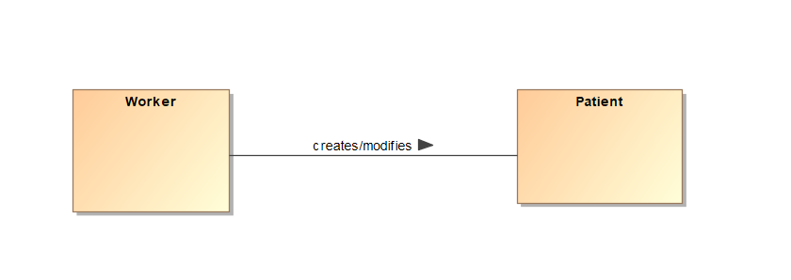

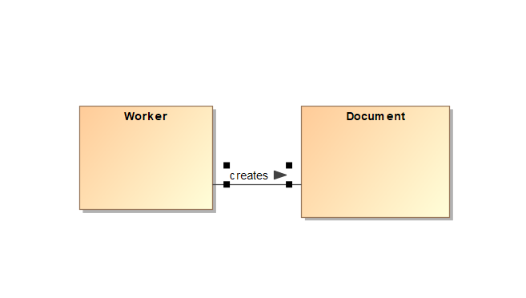

# Class Attributes

1. Worker

|  |  |  |
| --- | --- | --- |
| **Attribute Name** | **Attribute Type** | **Brief Description** |
| userID | String | The full name of the user |
| role | String | Role of the user. Can be an Administrator or Physician |
| profession | String | Profession of the user. Can either be a Doctor or Nurse |
| accountName | String | Account name will be required when logging in |
| password | String | Password will be required when logging in |

1. Document

|  |  |  |
| --- | --- | --- |
| **Attribute Name** | **Attribute Type** | **Brief Description** |
| documentName | String | Name of the document |
| patientID | Int | ID number of the patient related to the document |
| creationDate | Date | Date when the document was created |
| creatorID | String | UserID of the creator |
| modificationDate | Date | Date when the document was modified after creation |
| modifierID | String | UserID of the Modifier |

1. Patient

|  |  |  |
| --- | --- | --- |
| **Attribute Name** | **Attribute Type** | **Brief Description** |
| patientName | String | Name of the Patient |
| patientID | Int | Id number of the patient |
| address | String | Patients Adress |
| dateOfBirth | Date | Patients Date of Birth |
| height | String | Patients height |
| weight | String | Patients weight |
| bloodType | String | Patients’ Blood-Type |
| bedID | String | Id of their bed in the clinic |
| treatmentArea | String | What they are being treated for |
| treatmentRecords | Int | How many treatments the patient has gotten |
| patientDocuments | Int | The number of documents the patient has |

# Revised Class Diagram

